WATERLOO COUNTY TRACK WARS
Thursday May 1, 2025

Welcome to TRACK WARS with easy entries and Finish Lynx Photo timing.

Online entry procedures are open now on Athletic.net

Hosts: Waterloo Regions District School Board Schools

Location: Jacob Hespeler S.S. 355 Holiday Inn Drive, Cambridge, Ontario.
(This venue is located just off the 401 near Hwy 24)

Date: Thursday, May 1, 2025.

Jim Woolley  Meet Director | Darcy Mintz, Chuck Thompson  Officials
jim_woolley@wrdsb.ca | darcy_mintz@wrdsb.ca  charles_thompson@wrdsb.ca

Facilities: Jacob Hespeler Secondary School has an 8 lane track. All weather (rubber) surface on all runways, track surfaces, javelin and high jump fans. Shot and Discus circles are concrete. Portable toilets are available. Participants are responsible for the safety of their own belongings and medical needs.

MAXIMUM SPIKE LENGTH 6 MM ON ALL TRACK OR RUNWAY SURFACES

Eligibility: High School eligible as defined by OFSAA.

For safety reasons, throwing implements are only to be used in the supervised competition areas for Shot, Discus and Javelin. Also, Footballs, Frisbees and other throwing equipment are not allowed to be used at the JHSS Track and Field Facility. Please ensure athletes and spectators not involved in the throwing events stay well clear of the perimeter boundaries that are set up.

Awards

T shirts to all first place finishers in individual events and relays.

ENTRY FEE: $15.00 per athlete (they may compete in unlimited events)

MAXIMUM FEE: $ 600.00 per school

Make cheques payable to: District 8 Athletic Association

Guaranteed Entry Deadline: Wednesday April 16th
Schools that register by this date will be guaranteed entry into Track Wars this year

Schools that register between Thursday April 17th and Sunday April 27th will be accepted on a first come first served basis until we reach a maximum of 45 schools. We have found that if more than 45 schools register not all athletes get an opportunity to have three attempts in the field events and we get way behind in our track schedule

Entry fees must be paid at the registration table before school packages are released.

Registration: A registration table will be set up at the administration trailer located closest to the bleachers at the finish line.

Officiating: All duties will be carried out by WRDSB and WCDSB schools!

RESULTS: Live results can be found at http://www.kwtimers.ca/

Schedule of Track Events
(2025)

Please Note: Girls run before boys for all races.

Event Age Classes Contested Order

10:30 a.m. Sprint hurdles Novice/Junior/Senior Girls/Boys

11:30 a.m. 100m Novice/Junior/Senior Girls

1:30 p.m. 100 m Novice/Junior/Senior Boys

***3:00 p.m. 1500m Novice/Junior/Senior Girls/Boys
*** will move up start times if complete 100’s sooner

4:30 p.m. 4 x 100 m Novice/Junior/Senior Girls/Boys

6:00 p.m. 400 m Novice & Junior together/Senior Girls/Boys

7:15 p.m. Steeplechase OPEN Girls/Boys

Schedule of Field Events

 | Shot Put | Javelin | Discus | High Jump | Long Jump | Triple Jump
10:30 | JG | NB | NG | JB | SG | SB
11:45 | SG | SB | JB | NG | NB | JG
1:00 | NB | NG | JG | SG | SB | JB
2:15 | SB | JB | SG | NB | JG | NG
3:30 | NG | JG | NB | SB | JB | SG
4:45 | JB | SG | SB | JG | NG | NB
Pole Vault  10:30 am |  |  |  | Open Girls
Pole Vault  1:30 PM |  |  |  | Open Boys

In terms of Field events, due to the number of entries we can’t guarantee a minimum number of attempts. In order to hopefully allow every competitor to get three attempts, the first attempt for all competitors will be measured. All subsequent attempts will only be measured if they are beyond the distance of the 8th place competitor from the first round. Adjustments may also be in place for pole vault and high jump depending on the number of competitors.

Track Wars 2025 Entries Information

Please see above for the two entry deadlines

All entries are to be done online at Athletic.net.

Please note that you do not have to enter the athletes or your relays into events online. You are just submitting your team list by age group. All entries will be done at the start line or at the field events. You can even import an excel sheet into the database in Athletic.net to enter your roster and then select the athletes that you want to come to Track Wars.

When you are logged into Athletic.net and have created your account and added Track Wars 2025 to your team calendar, please do the following.

1. Icon beside your name (top right)
2. Team Home
3. Track Wars 2025 (From within your 2025 Outdoor Calendar)
4. Register Athletes (Blue Button)
5. Click on the Blue words (Roster Only) for Men and Women and select an age group for each athlete. (Novice (N) Junior (J) or Senior (S).

The picture below shows you what your entries will look like when you are finished. The athletes with the Blue Hi-lited division beside their names will be entered into the meet.

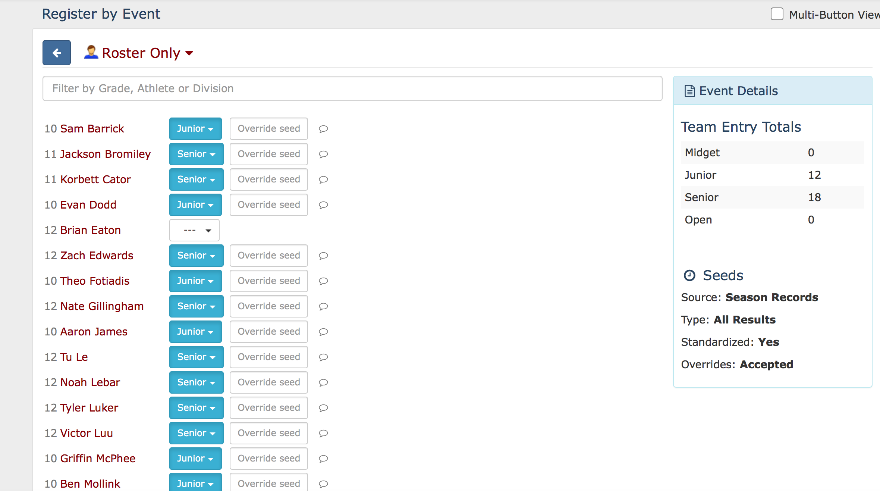

See you soon at JHSS!!!

